TUGAS UI/UX TERSTRUKTUR 11
PENGEMBANGAN PERANGKAT LUNAK



Abdullah Qa’id Mu’aadz | 22255601001

PeTIK II Jombang YBM PLN Tahun Akademik 2022/2023
Denanyar Utara, Plosogeneng,Kec. Jombang,
Kabupaten Jombang, Jawa Timur
Internasionalisasi dan Aksesibilitas
dalam Graphics, Icons, Images & Warna

Internasionalisasi & Aksesibilitas
- Saat ini Internet dan pasar perangkat lunak bersifat global. Internet membuat pengguna melintasi batas budaya dan bahasa yang tak ada habisnya, dengan persyaratan, konvensi, kebiasaan, dan definisi penerimaan masing-masing
- Pemahaman dan ingatan dapat ditingkatkan saat informasi disajikan sesuai dengan budaya (Spyridakis dan Fukuoka, 2002).
- Untuk membuat suatu produk dapat diterima di seluruh dunia, produk tersebut harus diinternasionalkan. Suatu sistem juga harus dirancang agar dapat digunakan oleh banyak orang yang hampir tidak terbatas, dapat diakses oleh siapa saja yang ingin menggunakannya. Konsep desain yang digunakan untuk mencapai tujuan ini disebut internasionalisasi dan aksesibilitas.
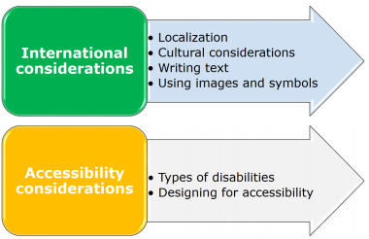

Lokalisasi
Kapan melakukannya:
- Ketika pasar hanya memiliki sedikit bahkan tidak ada penutur bahasa Inggris.
- Bila terjemahan diwajibkan oleh hukum atau kebiasaan.
- Ketika menginkan pasar seluas mungkin.
Kapan tidak melakukannya:
- Ketika penonton sudah familiar dengan bahasa Inggris.
- Ketika biaya perkuatan atau penulisan ulang perangkat lunak sangat mahal

Pertimbangan Budaya
- Power Distance - Jarak kekuasaan adalah tingkat penerimaan ketidaksetaraan kekuasaan dan otoritas
- Individualisme (vs. kolektivisme) mencerminkan seberapa baik integrasi seseorang ke dalam kelompok yang lebih besar.
- Maskulinitas (vs. feminitas) adalah keseimbangan antara ketegasan atau ketangguhan dan dukungan atau kepedulian.
- Uncertainty avoidance - Penghindaran ketidakpastian adalah tingkat ketidaknyamanan dengan kondisi yang tidak terstruktur dan berpotensi tidak dapat diprediksi.
- Orientasi jangka panjang (vs. jangka pendek) adalah trade-off antara penghargaan jangka panjang dan pengakuan langsung.
- Indulgence - Dimensi ini didefinisikan sebagai sejauh mana orang mencoba mengendalikan keinginan dan impuls mereka, berdasarkan cara mereka dibesarkan

Indonesia
- PDI(78) a high level of inequality of power and wealth within the society.
- UAI(48) more moderated influence of this Dimension within the Indonesian society. In an effort to minimize or reduce this level of uncertainty, strict rules, laws, policies, and regulations are adopted and implemented.
- IDV (14) the Indonesian society is Collectivist as compared to Individualist
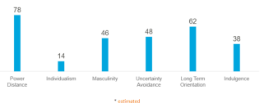

Word and Text

- Use very simple English
- Avoid
- Acronyms and abbreviations
- Slang or obscure phrasing
- Local or computer jargon
- A telegraphic/ over friendly writing style
- Culturally specific examples.
- Adhere to local user language idioms and cultural contexts
- Keep the original term for words that cannot be translated
- Allow additional screen space for the translation • Position icon captions outside of the graphic
- Modify mnemonics for keyboard access
- Adhere to local formats for date, time, money, measurements, addresses, and telephone number

Graphic, Icon, and Images

- Adhere to local cultural and social norms
- Use internationally accepted symbols
- Develop generic images
- Review proposed graphical images early in the design cycle
- Be particularly careful with
- Religious symbols (crosses and stars)
- The human body
- Women
- Hand gestures
- Flags
- Controversial geographic maps
- The cross and check for check boxes

Indonesia
- PDI(78) a high level of inequality of power and wealth within the society.
- UAI(48) more moderated influence of this Dimension within the Indonesian society. In an effort to minimize or reduce this level of uncertainty, strict rules, laws, policies, and regulations are adopted and implemented.
- IDV (14) the Indonesian society is Collectivist as compared to Individualist

Warna
- Colors Wheel
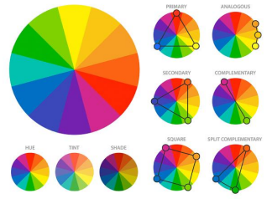

- Basic Guide
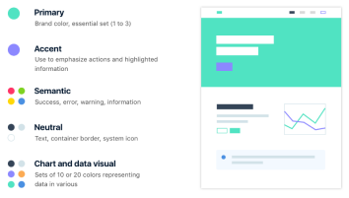

- Color Pallete
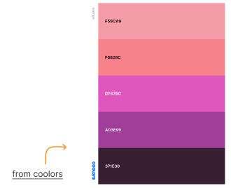

Color, Sequence, & Functionality
- Adhere to local color connotations and conventions
- Provide the proper information sequence
- Provide the proper functionality, Remove all references to features not supported

Aksesibilitas
- Accessibility means a system must be usable by an almost unlimited range of people
- Design objectives in creating accessibility for users with disabilities are:
- Minimize all barriers that make a system difficult, or impossible, to use.
- Provide compatibility with installed accessibility utilities.

- Types of disabilities:
- Visual → reduced visual acuity to total blindness.
- Hearing → inability to detect certain sounds to total deafness.
- Physical → movement difficulties in, or an inability to, perform certain physical tasks such as moving a mouse, or accurately striking a single keyboard key.
- Speech → or language difficult to read and write
- Cognitive → memory impairments and perceptual problems.
- Seizure → disorders sensitive to visual flash rates, certain rates triggering seizures

Desain Aksesibilitas
- Consider accessibility issues during system planning, design, and testing.
- Provide compatibility with installed accessibility utilities.
- Provide a customizable interface.
- Follow standard Windows conventions.
- Use standard Windows controls.
- Assure online forms can be easily completed

Visual Disabilities
- Ensure compatibility with screen-review utilities and screen-enlargement utilities
- Screen components:
- Include meaningful screen and window titles.
- Provide associated captions or labels for all controls, objects, icons, and graphics.
- Include graphical menu choices.
- Provide a textual summary for each statistical graphic.
- Allow for screen element scalability.
- Support system settings for high contrast for all user interface controls and client area content.
- When a high contrast setting is established, hide any images drawn behind the text to maintain screen information legibility.
- Avoid displaying or hiding information based on the movement of the pointer. Exception: Unless it’s part of the standard interface (example: ToolTips).

- Keyboard:
- Provide a complete keyboard interface.
- Provide a logical order of screen navigation.
- Color:
- Use color as an enhancing design characteristic.
- If used, considers
- color combinations
- lightness contrast between foreground and background color
- lightness contrast between colors in the color spectrum (blues and reds)
- Avoid combining dark colors from the middle of the spectrum with light colors from either end of the spectrum
- Do not define specific colors
- Use tools to verify what colors will look like when seen by colordeficient people

Hearing Disabilities
- Provide captions or transcripts of important audio content.
- Provide an option to display a visual cue for all audio alerts.
- Provide an option to adjust the volume.
- Use audio as an enhancing design characteristic.
- Provide a spell-check or grammar-check utility.

Physical Movement Disabilities
- Provide voice-input systems
- Provide a complete and simple keyboard interface
- Provide a simple mouse interface
- Provide on-screen keyboards
- Provide keyboard filters

Cognitive Disabilities
- Permit modification and simplification of the interface.
- Limit the use of time-based interfaces.
- Do not briefly display critical feedback or messages and then automatically remove them.
- Provide an option to permit the user to adjust the length of the time-out

Cognitive Disabilities
